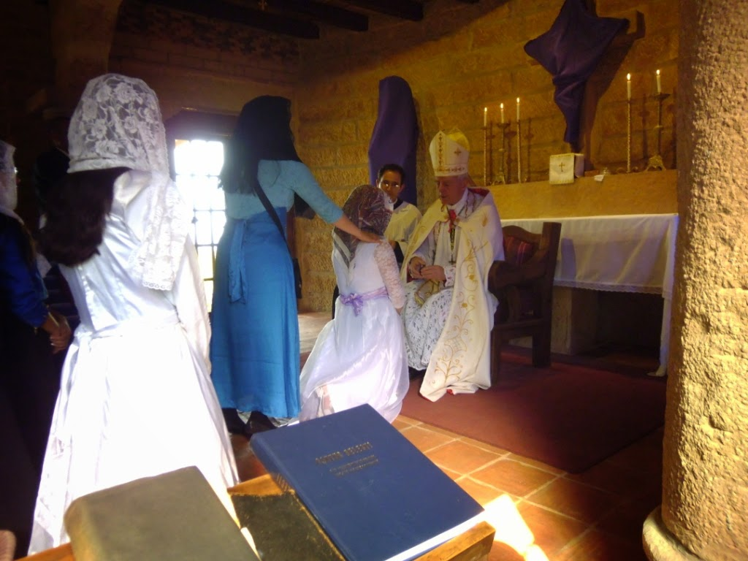

Here is the proposed schedule for Confirmations in America.

Post Falls June 1 @ 9:00 AM

Phoenix, AZ June 3 @ 6:00 PM

Minneapolis June 5 @ 6;00 PM

Boston, Ky June 6-8

Boston, Ky June 8 10:00 AM

Sparta, NJ June 10, 6:00 PM

